PROPOSED SOLUTION DOCUMENT

Novelty:

* Artificial intelligence offers unparalleled opportunities of progress and applications in nutrition. There remain gaps to address to potentialize this emerging field.
* Recently, there has been an increase in demand from common people for fresh, nutritious foods.
* This new trend shifting towards safe and nutritious foods has resulted in the development of analysing nutrition and consuming food that helps to maintain fitness with the help of fitness analyser.
* In this project, the image of food is processed using AI to find its corresponding nutrients (eg; carbohydrate, sugar, fat content etc.,).

Feasibility of idea:

* This idea can be achieved through AI with the help of ANN, CNN models to process the image and classify them. This classification gives the output and its corresponding nutrients are computed.
* This can be made convenient by creating the software which gives the expected result.
* Market survey to collect availability of foods, household food habits survey and identification of inexpensive and nutrient-rich local foods.

Business model: 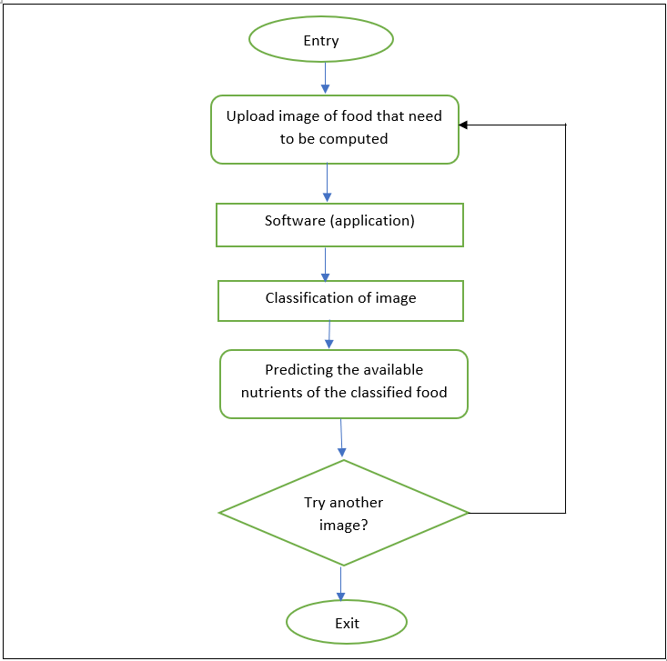

Social impact:

* The relationship between an individual's social, psychological, and cultural environment and his or her nutritional status is one of both cause and effect.
* Cultural patterns, economic stability, and attitudes toward health and disease all affect an individual's eating behaviour.
* With the use of this software one can keep track of how much nutrients he/she intake and also can balance their diet.

Scalability of solution:

* Scalability refers to the ability of this software project to perform well under an increased or expanding workload.
* By scalability software maintains or increase its level of performance. Server virtualization reduces physical server sprawl.
* Virtualization enables to create and abstract multiple virtual instances on a single server. And can isolate these virtual environments, which means you can run several independent OSes with different configurations on the same server.